**Node-API-Knex Guide**

**Part 1 Instructions**

In this demo, We would be setting up a Node project with Postgres database and Knex query builder. In this demo, we will demonstrate how to perform database migration and seeding dump data. We’ll create two routes, as shown below.

* GET: / todo |  Get all tasks
* POST: /todo | Create new task
* GET: /todo/:todoId | Get a task
* PUT: /todo/:todoId | Update a task
* DELETE: /todo/:todoId | Delete a task

**Part 2 How to run**

1. **Set up Express Server**

Follow guide on <https://expressjs.com/en/starter/installing.html> to

* init the npm project: npm init
* install the express: npm install express
* set up the app.js helloword

app.js:

| const express = require('express')  const app = express()  const port = 3000  app.get('/', (req, res) => {  res.send('Hello World!')  })  app.listen(port, () => {  console.log(`Example app listening on port ${port}`)  }) |
| --- |

1. **Install Knex**

| npm install knex pg |
| --- |

1. **Set up knexfile.js**

<https://knexjs.org/guide/migrations.html#knexfile-js>

| // Holds the Database connection config  module.exports = {  client: 'pg',  connection: {  host: "localhost",  port: 5432,  user: "postgres",  database: "chapter4_demo",  password: "123456",  }  } |
| --- |

1. **Migration data**

Create a new migration file

| npx knex migrate:make create_todo_table |
| --- |

1. **Fill in the upgrade and downgrade function in the migration file in the migrations/ folder:**

| exports.up = function(knex) {  // Create table TODO  return knex.schema.createTable("todo", (table)=>{  table.increments("id").primary()  table.text("task", 128).notNullable()  table.text("description", 128)  })  };  exports.down = function(knex) {  // Drop table TODO  return knex.schema.dropTableIfExists("todo")  }; |
| --- |

1. **Run the migration file**

Migrations allow for you to define sets of schema changes so upgrading a database is a breeze. To run the migrations, you can run the command below:

| npx knex migrate:latest |
| --- |

1. **Set up the Seed Data**

<https://knexjs.org/guide/migrations.html#seed-cli>

* Create a folder “seeds”
* Create a file seed.js

seeds/seed.js:

| exports.seed = function(knex) {  return knex("todo").insert([  {task: "Task 1", description: "Task 1 description"},  {task: "Task 2", description: "Task 2 description"},  {task: "Task 3", description: "Task 3 description"},  ])  } |
| --- |

1. **Insert the Seed Data**

Seed files allow you to populate your database with test or seed data independent of your migration files. To run the seeds files you can run the command below on your terminal

| npx knex seed:run |
| --- |

After all, your folder should look like this:

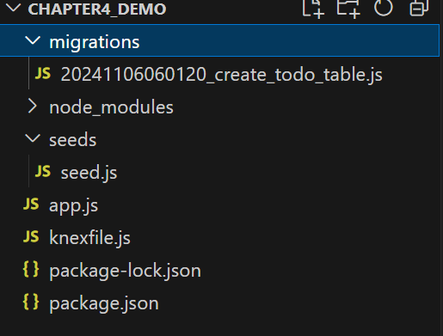

1. **Start service**

| node app.js |
| --- |

**Part 3 Connect DB in app.js**

Import the database configuration from knexfile and start the database connection:

Add in app.js

| // Import the db config from knexfile.js  const dbConfigs = require("./knexfile")  const knex = require("knex")(dbConfigs) |
| --- |

Add Get /todo API to get all todo items in the database:

| // GET /todo  app.get('/todo', (req, res)=>{  return knex("todo").select()  .then((value)=>{  return res.json(value)  })  }) |
| --- |

Use Postman to check the GET /todo API:

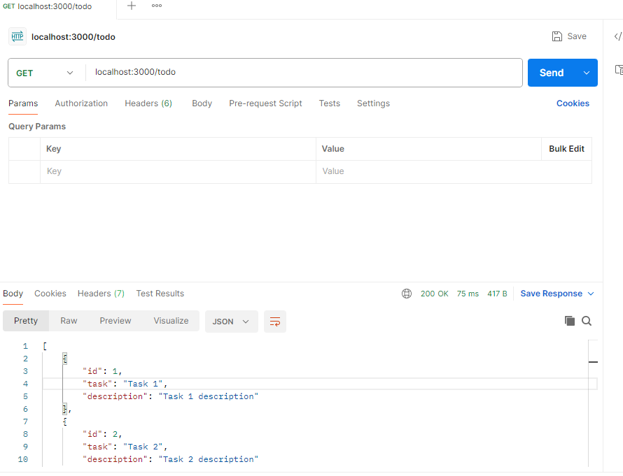

Add in app.js just below const app = express():

| // Enable express app to parse JSON body  app.use(express.json()) |
| --- |

Add Post /todo API to insert a new todo item:

| app.post('/todo', (req, res)=>{  const task = req.body  return knex("todo").insert(task).then(value=>{  res.json(value.rowCount)  })  }) |
| --- |

Use Postman to insert a data:

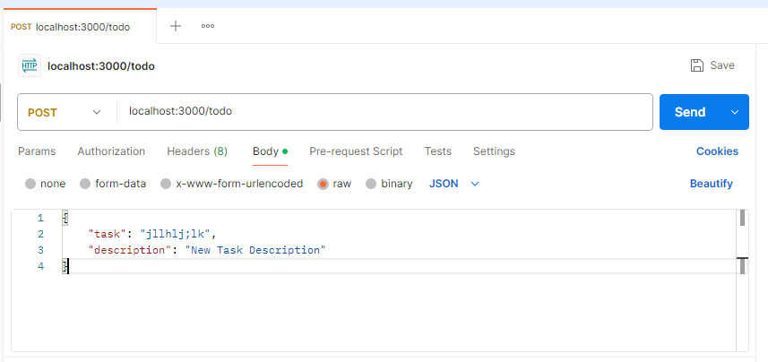

Add Put /todo/:todoId API to insert a new todo item:

| // PUT /todo  app.put('/todo/:todoId', (req, res)=>{  const todoId = req.params.todoId  return knex("todo").where({  id: todoId  }).update({  task: req.body.task,  description: req.body.description,  }).then((value)=>{  return res.json(value)  })  }) |
| --- |

Use Postman to update a data:

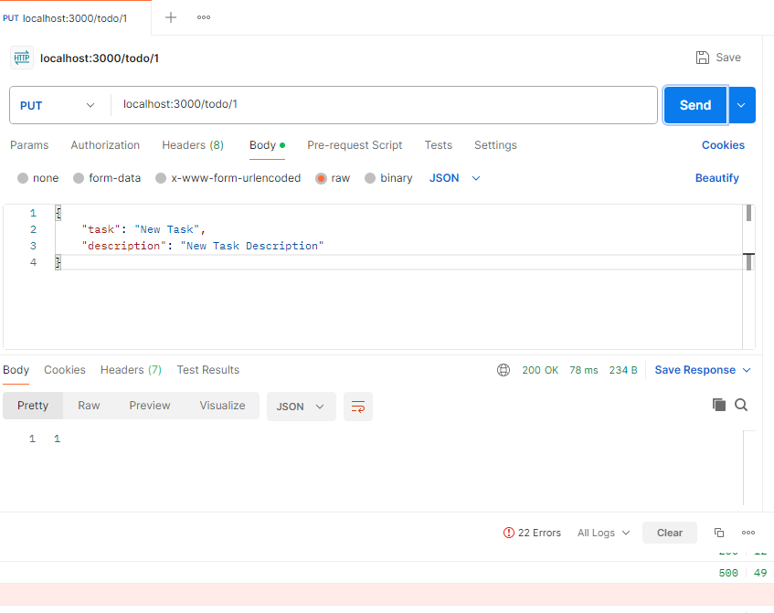

Add Delete /todo/:todoId API

| // Delete /todo/:todoId  app.delete('/todo/:todoId', (req, res)=>{  const todoId = req.params.todoId  return knex("todo").where({  id: todoId  }).del().then((value)=>{  return res.json(value)  })  }) |
| --- |

Use Postman to delete a data again:

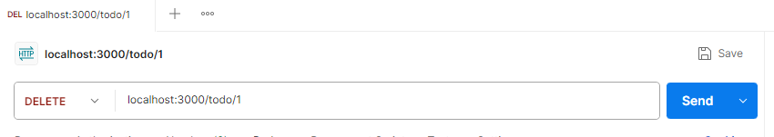

Add Get /todo/:todoId

| // Get /todo/:todoId  app.get('/todo/:todoId', (req, res)=>{  // Get a TODO item  const todoId = req.params.todoId  return knex("todo").where({  id: todoId  }).first().then((value)=>{  // Return not found if the todoId cannot be  // found  if(!value){  return res.status(404).json({  "message": "todo not found"  })  }  return res.json(value)  })  }) |
| --- |

Use Postman to get a TODO item

